File IO Basics and Text File Handling assignments

Mandatory

- Read 2 lines of text as single command line argument, validate the arguments, extract the lines, write to file “fout.txt”. Now open file read the content and display. Implement the functions
int write(FILE *fptr, char *line);
int read(FILE *fptr, char *linebuf);i
[Assume maximum line length as 80]
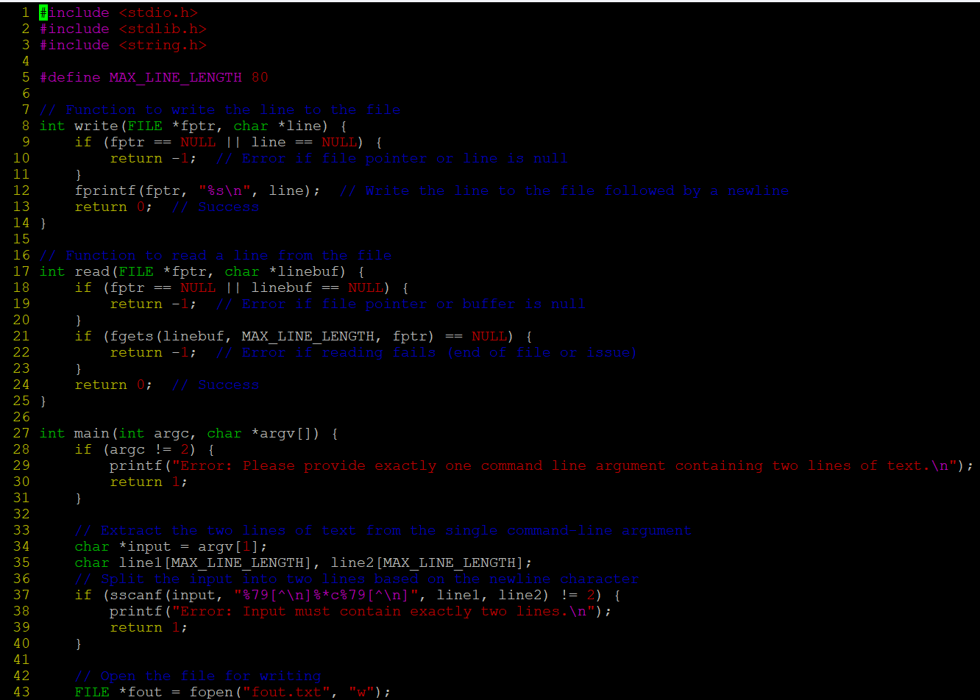

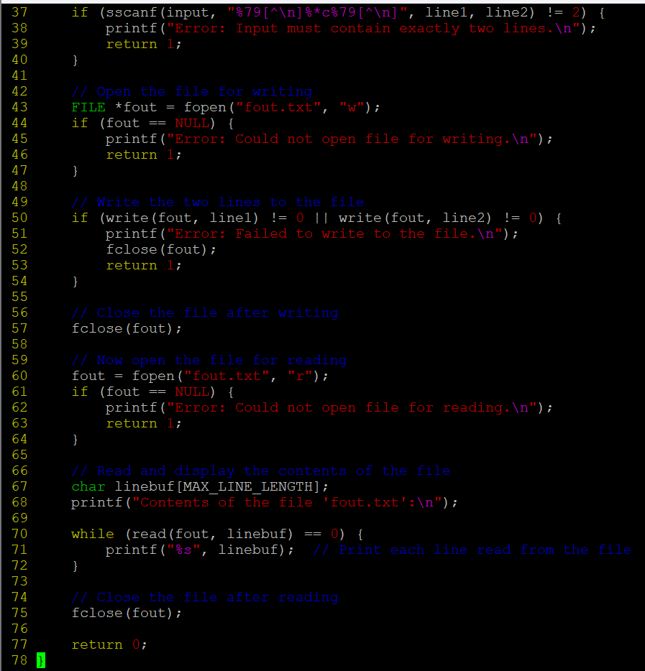
- Copy the file “string_process_prg.c“ to your local directory. Consider a line length of 80 characters. Create “input.txt” file with appropriate data.
- Fix the issues (warnings and errors in file).
- Implement display()
- Test the program for the expected output i.e to display file contents.
- Free the allocated memory

